# **CDMH Query Management**

## **Introduction**

## This document contains steps for navigating, creating and managing queries built using Query Management tool hosted on Adeptia Connect.

## **Use Case**

Identify a group of patients who have a certain set of cancer diagnosis but do not have a set of connective tissue diagnosis. Then give them a set of medications and look to see if they later develop a set of connective tissue diagnosis after getting the medications

## **Access to Adeptia Connect**

Below is the URL for Adeptia Connect DEV.

<https://cdmhdev.ncats.io:8443/#login>

Access to Adeptia Connect is required to build or manage queries.

## **Query Builder**

Query Builder UI allows user to build a query by specifying conditions for selected controlled vocabularies. Once logged in to Adeptia Connect, navigate to My Solutions > QueryManagement > Query Builder Tab

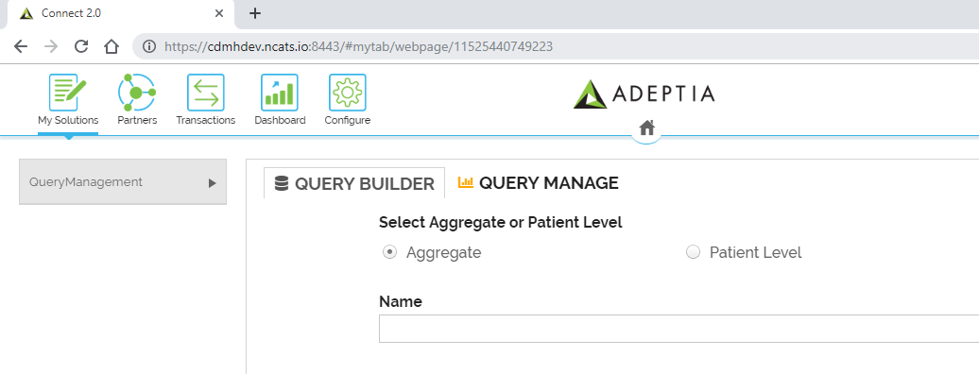

Components of Query Builder

1. Aggregate or Patient Level (Radio Button): User option to specify type of results.
2. Name, Description, Comments (TextBox): User input related to the query
3. Age Group(Slider): Age at the time of last encounter/visit
4. Time Period (Slider): Give me all patients diagnosed with (**) after first receiving (*) following a diagnosis of (**)
5. Diagnosis Inclusive (Tree): Set of diagnosis from use case in ICD10 representation. A REST call is made based on the search string and results are represented in Hierarchical format for selection.
6. Diagnosis Exclusive (out of scope for Phase 1)
7. Medication (Tree): Set of drugs from use case in NDC representation. A REST call is made based on the search string and results are represented in Hierarchical format for selection.
8. Grouping (Radio Button): This option is displayed for Aggregate query option. Results are first grouped either by Diagnosis/Medication/Both.
9. Stratification (Combo Checkbox): Second level of grouping results by Gender/Race/Ethnicity/All. Available only for Aggregate query type.
10. Save: Query Builder UI allows to save query with partial information and come back to update the query.
11. Submit: To submit a query all fields are mandatory (except Diagnosis Exclusive). Once submitted, this query cannot be edited directly. To update or edit, the query needs to saved as new query from Query Manage UI and updated.
12. Reset: Reset the UI screen to start new.

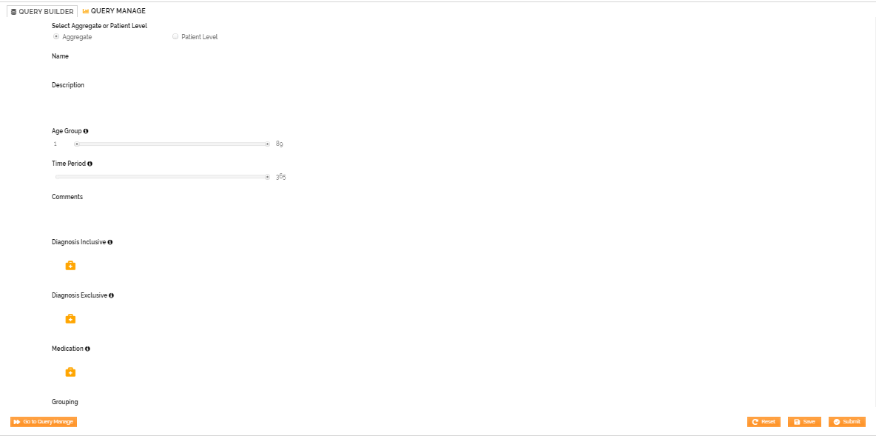

For a query submitted successfully, a query id (query request id) is assigned and displayed on Query manage screen.

## **Query Manage**

Query Manage UI provides option to edit a saved query, track a submitted query or view results when available. Once logged in to Adeptia Connect, navigate to My Solutions > QueryManagement > Query Manage Tab

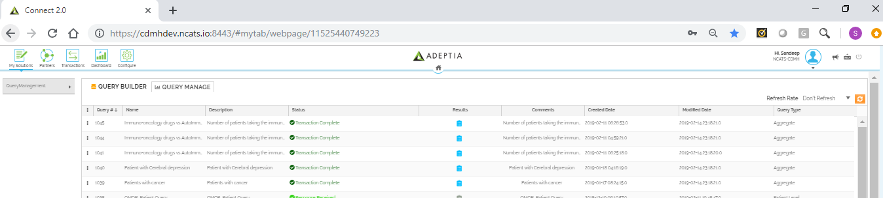

Query Manage grid contains below elements.

1. Menu icon: Click on Menu icon to view query or edit or save a previously stored query.

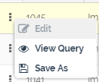

1. Query Id: Unique Identifier for each query submitted.
2. Name, Description, Comments: The user inputs from Query Builder
3. Status: Represent the current state of the query that was submitted.

Below are status and its meaning that a query can have

* Entry Saved – a saved query with partial input
* Inquiry Submitted – a submitted query
* Code Translated – User inputs are translated to Data Partner specific values
* Query Translated – Generated Data Partner specific query
* Query Submitted To Partner – Data Partner specific queries submitted to Partner
* Response Received – Response received from Partners
* Response Results Staged – Response results loaded to staging tables
* Loading to CDMH – Results to CDMH Bridg tables
* Partial Results Available – Results loaded to CDMH for atleast one Partner (not all)
* Transaction Complete - Results loaded to CDMH for all Partners
* Execution Error – Error in execution

1. Created Date, Modified Date: Dates when query first submitted and last updated date.
2. Query Type: Represent if the query is aggregate or patient level query.
3. Results: The Results icon is enabled to click only when the status of the query is either Partial Results Available or Transaction Complete.

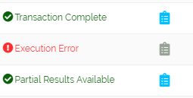

* Aggregate Results: Clicking on the Result icon for completed aggregate query will display a new window called Results Viewer with aggregated results from Partners. The Results Viewer for aggregate query also has the option to download the results in CSV format.

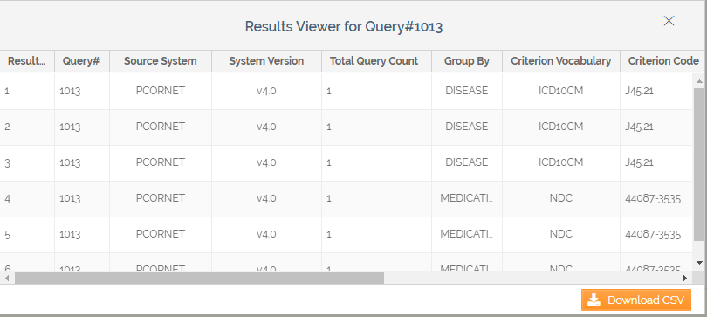

* Patient Level Results: Clicking on the Result icon for completed patient level query will display a new window called Results Viewer
  + Download Results: Results Viewer has option to select the CDMH tables and download the results in excel. When selected multiple tables, each sheets represents a table in the downloaded excel.

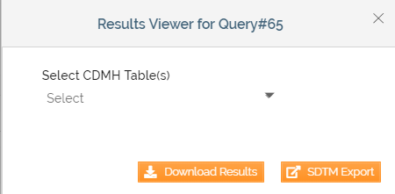

* + SDTM Export: Results Viewer for Patient Level results also have to option to export the results SDTM (xpt) format. Clicking SDTM Export downloads a zip containing xpt files for Demographics, Medical History and Concomitant Medications domains.

## **Database Tables Involved**

The following tables will be accessed/used by the Query Builder:

* CDMH.VOCABULARY - Reference table that captures standards used across Data Models.
* CDMH.VOC_MAPPING – Represents mapping (direction) between vocabularies
* CDMH.CODE_VALUE – Stores the actual data for each vocabulary.
* CDMH.CODE_MAPPING – Stores the mapping information at code level.
* CDMH.QUERY_REQUEST – Stores the user input selection from Query Builder

The diagnosis and medication information is retrieved from the CDMH.CODE_VALUE table.

The following tables will be accessed/used by the ETL during query processing apart from the CDMH BRIDG core tables that stores actual data.

* CDMH.QUERY_REQUEST – To retrieve user input.
* CDMH.CRITERIA_TRANS - Stores the translated codes for user input specific to a data partner
* CDMH.QUERY_REPR – Stores the translated query using the data partner specific values from CRITERIA_TRANS
* CDMH.RESULTS_FILE – Stores the results from partner.